Purpose: This Release to be signed by the ARTIST of a proposed pictorial postmark, when the artist is NOT THE SPONSOR of the postmark

Printed Name: ____________________________________ Citizen of (Country):__________________________________
Address:______________________________________________________________________________________________
Date Created: _________________ Profession/Title: _______________ Employer:___________________________
In consideration of good and valuable consideration, including the ability to participate in the United States Postal Service stamp program, the receipt and sufficiency of which is hereby acknowledged, I CONFIRM, REPRESENT, AND WARRANT THAT:
The Postmark Artwork
1. I personally designed and created the pictorial postmark, a copy of which is attached as Exhibit A to this Release (the “Postmark Artwork”).
2. I created the artwork (check the correct option):
____ as part of my employment duties; OR ____ on my own time, with my own materials and on my own initiative.
3. Attached as Exhibit B is a fully-complete and accurate chart identifying each graphical element in the Postmark Artwork, where it came from, and whether I obtained a release to use it.
4. I obtained all required rights and permissions for the Postal Service to use the Postmark Artwork as a pictorial postmark, and the Postmark Artwork does not infringe upon any copyright, trademark, trade dress, rights of privacy or publicity, patent rights or third party contract rights and does not contain libelous matter.

License to Postal Service
5. I grant to the Postal Service a non-exclusive, irrevocable, worldwide, perpetual, royalty-free, sublicensable license to use the Postmark Artwork and my name in connection with the issuance of postmark(s) and in connection with the use, distribution, sale, and marketing, in all media now known or later invented, of stamps and philatelic products.
6. This Release is binding upon, and inures to the benefit of, myself and the Postal Service, and our respective (as applicable) officers, directors, employees, heirs, devisees, legatees, representatives, guardians, conservators, administrators, successors, assigns, transferees and estates.
7. The Postal Service is not obligated to use or allow the publication of the Postmark Artwork if it decides not to do so.

Formalities
- I am under no obligation to sign this Release, but if I do sign I do so voluntarily, without duress, having had the chance to consult an attorney and fully understanding my rights.
- I will keep the fact that I have signed this Release and the details of it confidential.
- This Release is governed by and interpreted solely in accordance with the principles of U.S. federal law, and, to the extent that there is no relevant federal law, the laws of the State of New York. It may be signed by electronic means, which shall indicate authorization and have the same effect as a written signature.
- I declare under penalty of perjury of the laws of the United States of America that the foregoing is true and correct.

____________________________________________________ ________________________
Signature Date
EXHIBIT A
THE PICTORIAL POSTMARK ARTWORK
As an example, please see the postmark created last year in Cedar Glen:
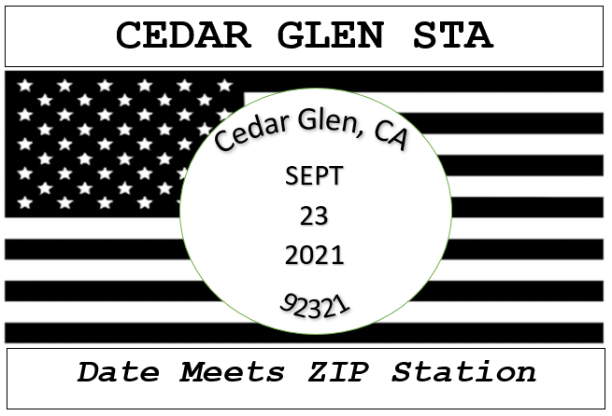

[insert or attach picture of pictorial postmark here]

EXHIBIT B
CHART OF GRAPHICAL ELEMENTS

The artist must fill out and complete the below chart (see sample). Each graphical element contained with the Postmark Artwork shown in Exhibit A must have an entry in the chart. A graphical element consists of:
- Any photograph
- Any drawing, or clipart (list separately)
- Any font used within the Postmark Artwork

Graphical Element | Creator/Owner | How element was obtained for artwork | Was permission obtained to use element?
 | Drawn by artist  SAMPLE | I personally drew this artwork | Because I drew the artwork from my imagination and did not base it on anything, I have permission to use it
 | Shutterstock images  (shutterstock.com/pic-316496750/) | I searched on Shutterstock and downloaded image | Yes, I purchased the image from Shutterstock
Font for title “SAMPLE POSTMARK” | Font is Times New Roman | Came installed on my computer | No, it is my understanding that I can use it because it was preinstalled on my computer.

[Artist to complete below chart ]

Graphical Element | Creator/Owner | How element was obtained for artwork | Was permission obtained to use element?

